• •  **Course Outcome to be covered: CO1:** Merits of digital systems, various number systems and their applications.

**Lecture Outcome:** Students will know how to convert one type of number system to another and their equivalent in another number system

• **Conversion of Number System:** All other number system to decimal

* Binary to Decimal
* Octal to Decimal
* Hexadecimal to Decimal

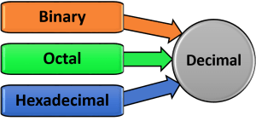

 Fig.[ 2.3]: Other number system to decimal

**Binary to Decimal**

Multiply the digit with 2(with place value exponent). Eventually add all the multiplication becomes the Decimal number.

**Example**: Convert 11011001 into decimal.

Sol.

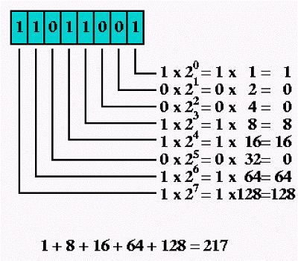

Fig [2.4] Example of binary to decimal

**Example:** Convert binary number 1010.1011 into decimal number.

Sol. Since there is a binary point here with fractional part:

Fig [2.5]: Example of binary to decimal

**Octal to Decimal:**

**Example:** Convert (345)8 into decimal.

Sol.

345 octal = (3 * 82) + (4 * 81) + (5 * 80) = (3 * 64) + (4 * 8) + (5 * 1) = 229 decimal

**Example:** Convert (7.12172)8 into decimal.

Sol.

**Hexadecimal to Decimal**

**Example:** Convert hexadecimal number (1AB)16 into decimal number.

Sol.

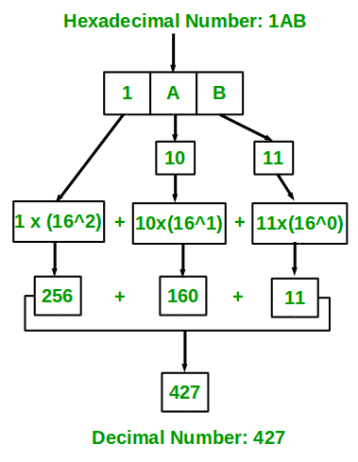

**Binary-Hexadecimal**

An equally easy way to convert from binary to hexadecimal is to group binary digits into sets of four, starting with the least significant (rightmost) digits.

Binary: 11100101 = 1110 0101

Then, look up each group in a table:

**Example:** Convert (110111110111.00001010)2 it to hexadecimal**.**

Sol.

Ans. (DF7.0A)16

**Hexadecimal to Binary**

Converting from hexadecimal to binary is as easy as converting from binary to hexadecimal. Simply look up each hexadecimal digit to obtain the equivalent group of four binary digits.

**Example:** Convert (240A.3C)16 into binary .

               2           4            0           A  .         3        C

                0010    0100     0000      1010 .    0011     110

 Ans. (0010010000001010.00111100)2

**Binary to Octal**

An easy way to convert from binary to octal is to group binary digits into sets of three, starting with the least significant (rightmost) digits.

**Example**: Convert (101111.11 0)2 into octal

Sol. 1 0 1 1 1 1 . 1 1 0

Ans. (56.6)8

**Octal to Binary**

Converting from octal to binary is as easy as converting from binary to octal. Simply look up each octal digit to obtain the equivalent group of three binary digits.

**Example:** convert (35.346)8 to binary

sol.

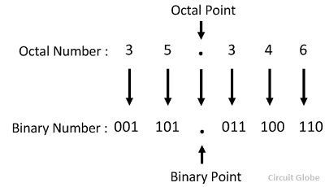

Ans. (001101.011100110)2

**\*NOTE:** Drop any leading zeros or pad with leading zeros to get groups of four binary digits (bits): Binary 011100101 = 1110 0101. Then, look up the groups in a table to convert to hexadecimal digits.

**Example:** Convert (123)8 into (?)16

Sol.

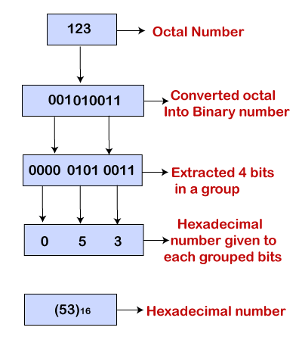

**Hexadecimal to octal:**

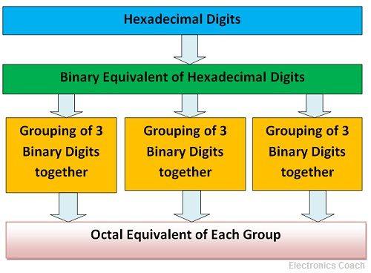

**Example:** Convert (1AC)16 into (?)8

Sol.

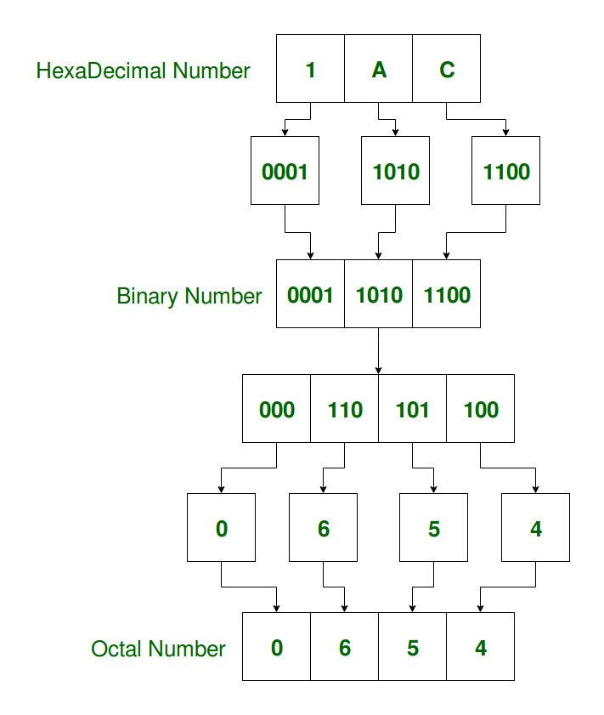

**Points to Remember:**

* Drop any leading zeros or pad with leading zeros to get groups of three or four.
* When converting from octal to hexadecimal, it is easier to first convert the octal number into binary and then from binary into hexadecimal.
* When converting from hexadecimal to octal, it is easier to first convert the hexadecimal number into binary and then from binary into octal.
* While converting from hexa to binary obtain group of four binary digits and from binary to hexa pair the binary bits in group of four.
* While converting from octal to binary obtain group of three binary digits and from binary to octal pair the binary bits in group of three.
* Start the pairing in case of fractional number from the decimal point i.e decimal point to left pairing and decimal point to right.

**Applications:** These are basic applications **:**

* Computer language and programming
* Digital encoding
* Digital binary clock,

Frequently used in everyday life in:

* Accounting
* Calendar systems
* Financial systems or daily routine counting.

• **Books:**

[**https://www.amazon.in/Electronics-Analog-Digital-Nagrath-I-J/dp/8120348028**](https://www.amazon.in/Electronics-Analog-Digital-Nagrath-I-J/dp/8120348028)

Electronics: Analog and Digital by Nagrath I.J-Amazon link

**Lecture Notes:**

[**https://www.tutorialspoint.com/digital_electronics/index.asp**](https://www.tutorialspoint.com/digital_electronics/index.asp)

**Video Link:**

[**https://onlinecourses.nptel.ac.in/noc19_ee51/unit?unit=6&lesson=10**](https://onlinecourses.nptel.ac.in/noc19_ee51/unit?unit=6&lesson=10)

**References:**

[**https://www.google.com/search?q=number+system+in+digital+electronics&source=lnms&tbm=isch&sa=X&ved=0ahUKEwjOsbqmnvPiAhXPZCsKHXrSBJYQ_AUIESgC&biw=1366&bih=657#imgrc=DBR-RpBVZAmHDM:**](https://www.google.com/search?q=number+system+in+digital+electronics&source=lnms&tbm=isch&sa=X&ved=0ahUKEwjOsbqmnvPiAhXPZCsKHXrSBJYQ_AUIESgC&biw=1366&bih=657#imgrc=DBR-RpBVZAmHDM:)